
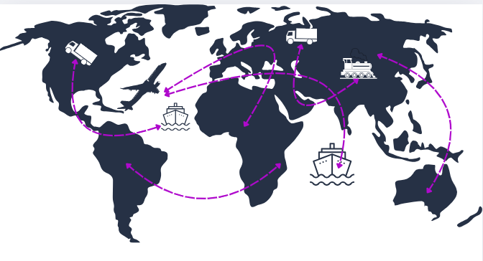

CONTENT
1) CUSTOMER INFORMATION 2
2) SHIPPING UNIT (BOX CARTON) INFORMATION 2
3) PRE-CONDITIONING 3
4) TRANSPORTATION SIMULATION TESTS 4
5) PACKAGING INTEGRITY TESTS AFTER TRANSPORTATION SIMULATION TESTS 6
6) PROCEDURES TO BE CARRIED OUT ON SAMPLES AFTER TEST 8
7) TRANSPORTATION VALIDATION PROTOCOL AND REPORT SERVICE 8
8) ADDITIONAL SERVICES 8
9) TERMS AND CONDITIONS 9
10) APPROVAL 10
11) EVALUATION 10

Transport simulation tests are conducted to simulate the actual transport conditions of your products and to verify that your product's performance or packaging integrity is maintained after exposure to these difficult conditions.
When deciding on transportation simulation tests, please consider your actual routes, seasonal changes, and the modes of transportation used (road, air, rail, sea, etc.)
If you would like our assistance with this matter, please send an email to info@nioreg.com

CUSTOMER INFORMATION
Contact  Person 1 | Name Surname | Click or tap here to enter text.
Contact  Person 1 | Title/Position | Click or tap here to enter text.
Contact  Person 1 | E-mail | Click or tap here to enter text.
Contact  Person 1 | Telephone | Click or tap here to enter text.
Contact  Person 2 | Name Surname | Click or tap here to enter text.
Contact  Person 2 | Title/Position | Click or tap here to enter text.
Contact  Person 2 | Contact Information | Click or tap here to enter text.
Company  Details | Company Name | Click or tap here to enter text.
Company  Details | Company Address  City, Country | Click or tap here to enter text.
Company  Details | E-mail | Click or tap here to enter text.
Company  Details | Telephone | Click or tap here to enter text.
Company  Details | Invoice Information | ☐ | Same as above information
Company  Details | Invoice Information | ☐ | Write if it is different from the information above.  Click or tap here to enter text.

SHIPPING UNIT (BOX CARTON) INFORMATION
Product name contained in the shipping unit (box carton) | Click or tap here to enter text. |  | Shipping Unit (Box Carton) Size Specifications
Is the shipping unit (box carton) at least double corrugated? | Choose an item. |  | Length | ? cm | cm
Shipping Unit (Boxes) Quantity | Click or tap here to enter text. |  | Height | ? cm | cm
Sample Storage Conditions | What is the temperature in Celsius? | °C | Width | ? cm | cm
Sample Storage Conditions | Humidity level? | % RH | Sample Weight | ? Kg | kg
*Please pay attention to the units.
Explanations
If you have different quantities of boxes of different sizes, you can enter a description here.

PRE-CONDITIONING
You can determine the test parameters yourself according to the conditions of your transportation route, or you can use our test parameter recommendation below, which complies with the ASTM D4332 standard.
If you do not want preconditioning, please indicate in the table.
☐ |  | ☐ |  | ☐ | 
Extreme cold  Temperature: -30 ±2 °C  Humidity: Uncontrolled humidity  Duration: ≥ 72 hours |  | Tropical  Temperature: 40±2 °C  Humidity: 90±5 %RH  Duration: ≥72 hours |  | Desert  Temperature: 60±2 °C  Humidity: <20 %RH  Duration ≥ 72 hours
If you request a parameter different from the parameters above, please fill in the table below.
Preconditioning Parameters | Temperature (°C) | Humidity (%RH) | Duration  (Hours) | Selection
Desired Condition | Click or tap here to enter text. | Click or tap here to enter text. | Click or tap here to enter text. | ☐
Desired Condition | Click or tap here to enter text. | Click or tap here to enter text. | Click or tap here to enter text. | ☐
Desired Condition | Click or tap here to enter text. | Click or tap here to enter text. | Click or tap here to enter text. | ☐
Check if you do not want preconditioning. |  |  |  | ☐
Explanations
Click or tap here to enter text.

TRANSPORTATION SIMULATION TESTS
The following tests are performed in sequence in accordance with ASTM D4169 Distribution Cycle (DC)13. Select the tests you require and the safety level. (Safety Level II is recommended for medical devices.)
Program | ASTM D4169 (DC 13) |  |  | Security  Level
Program A: Handling  (1.cycle) |  | Drop Test  ASTM D5276 | ☐ | Choose an item.
Program C: Vehicle Stacking |  | Compressive Test  In-vehicle stacking height (meters):  Click or tap here to enter text. | ☐ | Choose an item.
Program F: Loose Load Vibration | 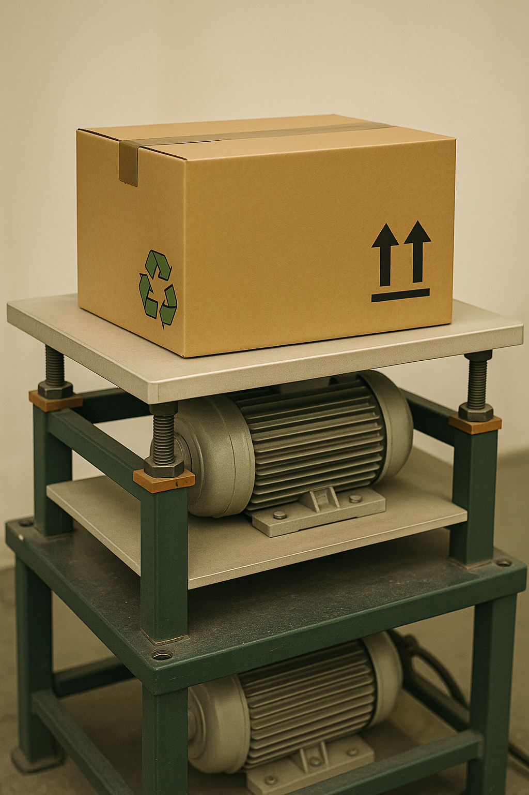 | Loose Load Vibration Test  ASTM D999 | ☐ | Choose an item.
Program I:  Low Pressure | 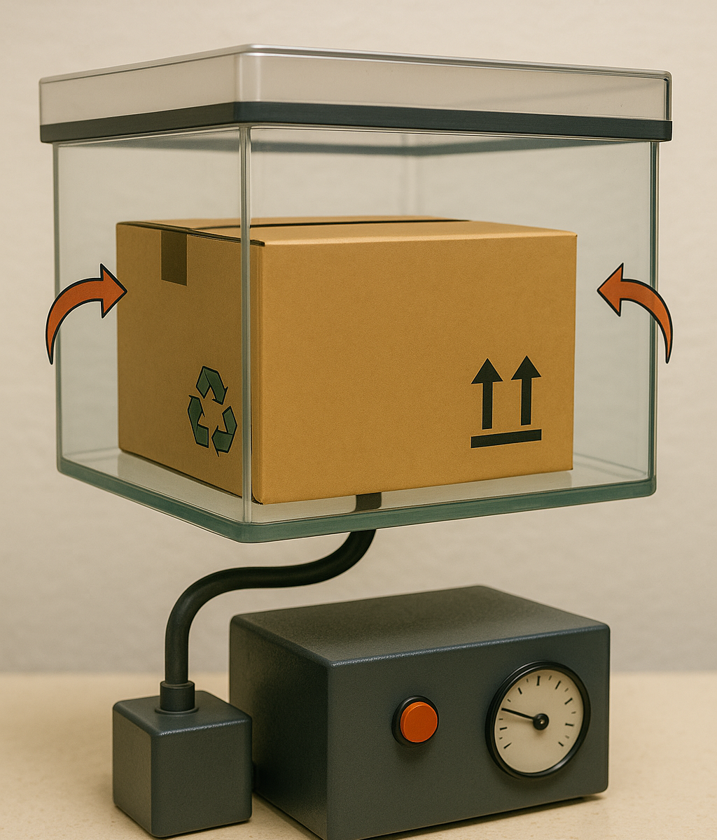 | High Altitude Test  ASTM D6653 | ☐ | NA
Program E:  Vehicle Vibration | 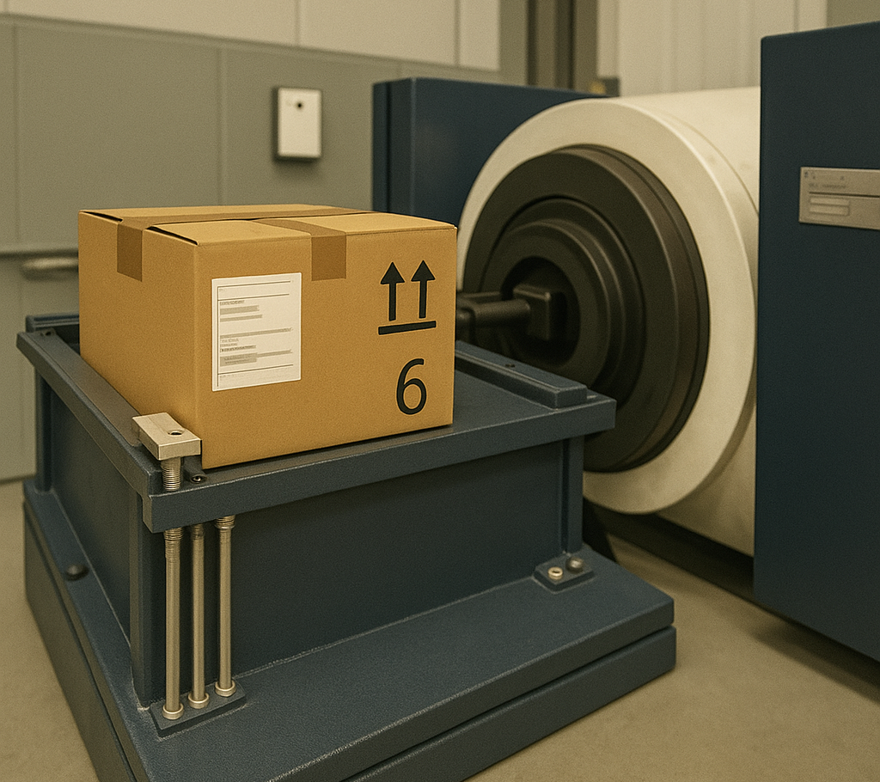 | Vehicle vibration  ASTM D4728 | ☐ | NA
Program J: Concentrated Impact |  | Concentrated Impacts Test  ASTM D6344  *This test is not required for double walled corrugated cardboard boxes. | ☐ | NA
Program A: Handling  (2. cycle) |  | Drop Test  ASTM D5276  *The final drop is applied from twice the height. | ☐ | Choose an item.
Information regarding security level:
The assurance level determines the rigor of the ASTM D4169 tests. The more sensitive the product and the higher the risk, Level I is selected; Level II is selected for average products; and Level III is selected for more durable products. For detailed information, see ASTM D4169.
If you want transport simulation with a parameter different from ASTM D4169 DC-13, please fill out the table below.
Test Name | Required Parameters | Selection
Click or tap here to enter text. | Click or tap here to enter text. | ☐
Click or tap here to enter text. | Click or tap here to enter text. | ☐
Click or tap here to enter text. | Click or tap here to enter text. | ☐
Explanations
Click or tap here to enter text.

Answer the following questions about your sample
How many different type of SAMPLEs are included in the Shipping Unit (Box)? | Click or tap here to enter text.
How many SAMPLEs are placed in the Transportation Unit (Box) in total? | Click or tap here to enter text.
Questions | Yes | No
Does the sample contain any explosive and/or flammable substances or gases? | ☐ | ☐
Does the sample contain a battery? | ☐ | ☐
Is there any liquid in the sample? | ☐ | ☐
Is there any oil in the sample? | ☐ | ☐
If your answer to at least one of the above three questions is yes, please provide additional information on the matter.
Click or tap here to enter text.

PACKAGING INTEGRITY TESTS AFTER TRANSPORTATION SIMULATION TESTS
We also offer the following testing services for your “primary packaging” contained in the box.
If you need packaging integrity tests, please fill out the table below.
Reminder: When determining the number of samples for packaging strength tests, you must have statistical justification. In addition, the number of samples to be used in Packaging Integrity Tests will also affect the number of Cartons/Boxes (shipping units) to be used in Transportation Simulation Tests.
Test Method | Standard Method |  | Sample Quantity | Is Preconditioning Required? | Desired Preconditioning Parameter
Visual Inspection |  | ASTM F1886/F1886M | ? sample | Choose an item. | Click or tap here to enter text.
Sealing Width Control |  | EN 868-5 | ? sample | Choose an item. | Click or tap here to enter text.
Package Tensile Strength | 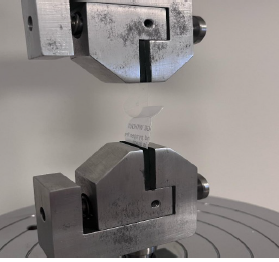 | ASTM F88/F88M  & EN 868-5 | ? sample | Choose an item. | Click or tap here to enter text.
Dye Penetration Test |  | ASTM F1929  Method A | ? sample | Choose an item. | Click or tap here to enter text.
Burst Test | 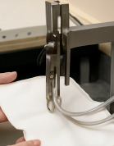 | ASTM F1140/F1140M  Method A  (Closed Package) | ? sample | Choose an item. | Click or tap here to enter text.
Burst Test |  | ASTM F1140/F1140M  Method B  (Closed Package) | ? sample | Choose an item. | Click or tap here to enter text.
Burst Test |  | ASTM F1140/F1140M  Method C  (Closed Package) | ? sample | Choose an item. | Click or tap here to enter text.
Burst Test |  | ASTM F2054/F2054M  (Closed Package) | ? sample | Choose an item. | Click or tap here to enter text.
Bubble Test |  | ASTM F2096  Method A | ? sample | Choose an item. | Click or tap here to enter text.
Bubble Test |  | ASTM F2096  Method B | ? sample | Choose an item. | Click or tap here to enter text.

Explanations
You can use the field below for any different packaging tests you require.
Click or tap here to enter text.

Request for declaration of conformity for packaging tests:
I do not want a declaration of conformity. | ☐
I would like a declaration of conformity. Please list the tests you require for the declaration of conformity below and tick your selection from the following decision rules.  Click or tap here to enter text. | ☐
☐ | Measurement results are reported by comparing them with standard limit values without taking measurement uncertainty into account.
☐ | Measurement and analysis results are reported appropriately when the upper limit value is not exceeded, taking into account the expansion coefficient k=2, and when the measurement uncertainty is added in the positive direction and exceeds the limit value.
☐ | Measurement and analysis results are reported as unsuitable if they exceed the upper limit value when the k=2 expansion coefficient is taken into account and the measurement uncertainty is added in the positive direction.
☐ | Measurement and analysis results are reported appropriately when the measurement uncertainty is added in the positive direction if the result is below the lower limit value, taking into account the expansion coefficient k=2, and when it is above the lower limit.
☐ | If the measurement and analysis results are below the lower limit value, taking into account the expansion coefficient k=2, they are reported as unsuitable when the measurement uncertainty is added in the positive direction and above the lower limit value.
☐ | Measurement and analysis results are reported appropriately when the measurement uncertainty is added in the negative direction if the result is above the lower limit value, taking into account the expansion coefficient k=2, and when it is below the lower limit value.
☐ | If the measurement and analysis results are above the lower limit value of the result, taking into account the expansion coefficient k=2, the measurement uncertainty is added in the negative direction; if they are below the lower limit value, they are reported as unsuitable.
☐ | Measurement and analysis results are reported appropriately when the upper limit value is exceeded, taking into account the expansion coefficient k=2, and the measurement uncertainty is added in the negative direction, but the limit value is not exceeded.
☐ | Measurement and analysis results are reported as unsuitable if the upper limit value is exceeded when the expansion coefficient k=2 is taken into account and the measurement uncertainty is added in the negative direction.

PROCEDURES TO BE CARRIED OUT ON SAMPLES AFTER TEST
Select your test reporting language: ☐ English ☐ English + Turkish
Action to be taken on the tested sample: ☐ Return ☐ Disposal
Delivery Type ☐ Electronic Copy / E-mail ☐ Hard Copy / Courier
Do you have an AGREED Cargo company that you would like to use for returning samples?
☐ | Yes | ☐ | No
Please specify the Cargo company you would like to use.
Click or tap here to enter text.

TRANSPORTATION VALIDATION PROTOCOL AND REPORT SERVICE
We also offer a validation protocol and report service that includes the selection criteria, sample numbers, and related details for your transport simulation tests. If you wish to use this service, please check the relevant box in the table below.
Would you like to request a Transportation Validation Protocol and Report service? | Yes | No
 | ☐ | ☐
Documentation Language
English-Turkish |  | ☐
English |  | ☐
I would like more information about the content of this service. |  | ☐

ADDITIONAL SERVICES
Packaging Validation | Protocol and Report Documentation | ☐
Packaging Validation | Packaging Integrity Tests | ☐
Accelerated Aging | Protocol and Report Documentation | ☐
Accelerated Aging | Exposure to desired conditions | ☐

TERMS AND CONDITIONS

1. NioReg Verification and Design Services Ltd. (herein referred to as NioReg) will perform the tests requested for the Customer in accordance with the terms and conditions contained herein.
2. It shall be the Customer's responsibility to ascertain and notify NioReg of the standards to which any sample submitted must conform in any country or territory in which it is intended to be sold.
3. The Terms and Conditions are the sole terms governing NioReg's relationship with the Customer. The Terms and Conditions may only be modified by an amendment expressed in writing and signed by a principal on behalf of NioReg. The Terms and Conditions contain the entire understanding of the parties and supersede any prior promises, representations, undertakings or implications.
4. NioReg will test any sample received from the Customer (the quantity, weight and size of the sample will be agreed between the Customer and NioReg). Under no circumstances will NioReg give any opinion as to the description, quantity or fitness for the purpose for which any sample is said to be intended.
5. The Customer also assumes all risks that the samples may cause.
6. A Test Report issued by NioReg shall refer only to the specimen actually tested and shall not refer or be deemed to refer to any specimen which may be said to have been obtained. NioReg will test and report on samples and any inferences that may be drawn from the outcome of such testing shall be at the sole discretion and responsibility of the Customer.
7. Test Reports prepared by NioReg are issued subject to the condition that they shall not be made publicly available or used in connection with, or for the purpose of, any advertising, publicity or promotional undertaking or material without the prior written consent of NioReg.
8. NioReg shall not be liable to the Client for any loss or damage due to NioReg's failure to meet the time(s) specified.
9. Under no circumstances shall the issue of any Test Report by NioReg involve or be deemed or purport to involve NioReg as a party or agent or otherwise in any relationship, contractual or otherwise, between the Client to whom the Test Report is to be sent.
10. In the event that NioReg is found liable for any loss, damage or destruction of samples subjected to testing by NioReg caused by the fault, negligence or willful default or act of NioReg's officers or agents, and in such event NioReg shall be liable up to and including the manufacturing price of the samples.
11. Samples that are not destroyed during testing may be destroyed at NioReg's sole discretion 15 days after the date of the Test Report, unless otherwise agreed in writing with the Customer in advance.
12. Payment Terms: Payable in advance before the test service.
13. In the event that the Client fails to make payment or is in arrears regardless of invoice, NioReg reserves the right not to issue any Test Report until all such arrears have been paid.
14. Testing is carried out to the best of NioReg's knowledge and capacity. The Test Report reflects NioReg's findings at the time of testing and does not release sellers, manufacturers from their contractual obligations or affect the buyers' right to compensation for any manifest and/or latent defects occurring during or after testing performed by NioReg.
15. Contracts and agreements to which these terms and conditions apply shall be construed in accordance with and governed by the laws of the Republic of Turkey and for the purposes of legal proceedings this agreement shall be deemed to be in the Republic of Turkey and enforced there.
16. NioReg shall not be liable for any loss or damage resulting from delay in or failure to perform any of its obligations hereunder due to any cause beyond NioReg's control (war, civil commotion, seizure, governmental restrictions of any kind; import or export regulations, strike or trade dispute, labor difficulties, breakdown of machinery, fire, power failure, flood, inundation, earthquake, bandam, loss or accident to cargo). In the event of the occurrence of such events, NioReg may cancel or suspend the contract in question with a refund of the amount paid and shall not assume any liability for any loss or damage caused thereby.
17. In cases where NioReg is required by law or contractually authorized to disclose confidential information, the customer or the relevant person will be notified of the information to be disclosed, unless prohibited by law.
18. Information about the client obtained from sources other than the client (e.g. complainant, regulatory authorities) will remain confidential between the client and NioReg. The provider of this information (source) will be kept confidential by NioReg and will not be shared with the customer unless approved by the source.
19. Except where legally required, all employees, including committee members, contractors, external organization personnel or persons acting on behalf of NioReg, shall keep confidential all information obtained or created in the course of performing NioReg's activities.
20. In cases where the sample is not delivered to the laboratory as specified by the customer requesting the laboratory activity, the results of the requested laboratory activity may be affected by the sample. In terms of the requested laboratory activities, our laboratory is not responsible for the results and deviation in the results affected by the information / samples provided by the customer.
21. or there are no limits in the legislation, standard or specification for the test concerned, Nioreg makes a decision without including measurement uncertainty when assessing the conformity of the results (Simple Acceptance Rule).
22. In the event of equipment failure during testing, the Customer will be notified by Nioreg within 3 business days.

APPROVAL
I confirm that the information written above is correct. I acknowledge that I have fully read, understood and accepted all provisions outlined in the terms and conditions.
Title
Click or tap here to enter text.
Name Surname
Click or tap here to enter text.
Signature Date
Click or tap here to enter text.
Signature

EVALUATION
This section will be filled in by NioReg.
Evaluated By
Name Surname | Click or tap here to enter text.
Date | Click or tap here to enter text.
Review Result | ☐ Appropriate, offerable.  ☐ Additional information should be requested.  ☐ Other | Detail  Please explain  Click or tap here to enter text.
Expert Opinion | if needed  Click or tap here to enter text.
Request No. | Click or tap here to enter text.
Notes | ☐The offer can be prepared in the same parameters as the request form.
Notes | ☐A different situation was requested by e-mail. (In this case, keep this request form with the incoming e-mail. )
Notes | Click or tap here to enter text.

It is requested to be used when the first contact person cannot be reached.
Contact NioReg for hard copy fees

